Detail Design Document

**MULTIMEDIA IMAGE PROCESSING Using OpenCV**

Votary Softech Solutions Pvt. Ltd.

Plot No: 76, Lumbini layout,  
Near Euro school,  
Gachibowli-I (V), Hyderabad,  
Telangana - 500032,  
India.

**Revision History**

|  |  |  |  |  |  |
| --- | --- | --- | --- | --- | --- |
| Version (x.y) | Date of Revision | Description of Change | Reason for Change | Affected Sections | Approved By |
|  |  |  |  |  |  |
|  |  |  |  |  |  |
|  |  |  |  |  |  |

**Approval History**

|  |  |  |  |
| --- | --- | --- | --- |
| Version (x.y) | Prepared By | Reviewed By/Date | Approved By/Date |
|  |  |  |  |
|  |  |  |  |
|  |  |  |  |

**Contents**

1 Define 4

1.1 Overview 4

1.2 Assumptions 4

1.3 Limitations 4

1.4 Deliverables.....................................................................................................4

1.5 Glossary 4

2 Specify 4

2.1 Scope 4

2.2 Design Approach 5

2.3 Alternative Design Approaches Considered 5

2.4 Module Design 5

2.4.1 Module Name and Description 5

2.5 External Interfaces 6

2.6 Design Tools 6

3 Architecture 6

3.1 Block Diagrams 6

3.2 Activity Diagrams/ Flow Charts 6

3.3 Deployment diagrams 6

3.4 State Transition Diagram (Optional) 6

3.5 State Transition Table 7

4 Design 7

4.1 Class Diagrams 7

4.2 Sequence Diagrams 7

4.3 Database Design 7

4.4 Wireframes 7

5 Implementation 7

5.1 Directory Structure 7

5.2 Libraries and Framework 7

5.3 Error Handling 7

5.4 Status Codes and Description 7

6 Validate 8

7 Deploy 8

8 Maintain 8

# Define

## Overview

The purpose of this document is to do the high level design by

identifying the different modules and interfaces. The modules involved in the design are image acquisition, image processing and image storage.

## Assumptions

Pre-configured data should be present in database for image processing.

## Limitations

Process one image at a time.

## Deliverable

Gateway

SQL Database

Application

## Glossary

| Term | Definition |
| --- | --- |
| OpenCV | Open Source Computer Vision. |

# Specify

All the modules are in the same network. Database and Gateway can be in a different Network.

## Scope

The modules can be change throughout life cycle vgate process and updated with corresponding documents with specified changes. Estimations and budget are not applicable.

## Design Approach

Image Acquisition system in the Gateway acquires raw data either from the Camera or from local storage or database .Image Acquisition system in the Gateway is implemented in python.

Image Processing System process data(captured image) to identify the things or Images or objects based on the pattern implemented by the Algorithm. Image Processing System in the Gateway is implemented in python.

Database to store the processed image and details from the image processing system which is implemented in python.

## Alternative Design Approaches Considered

It can also be done in C++ and Matlab.

## Module Design

### Module Name and Description

**Image Acquisition system** in the Gateway acquires raw data either from the Camera or from local storage or database.

**Image Processing System** process data(captured image) to identify the things or Images or objects based on the pattern implemented by the Algorithm.

**Database** to store the processed image and details from the image processing system.

#### Class Diagram

NA

#### API in Module

**create_gui():**

This is the api to called first when you execute the code,it will create the gui window with 3 button called Local Image,Camera,Database

**getFileName()**:

It will browse the image from local directories.and send that image path to imageprocess API

**imageprocess(imagepath):**

This API will locate the face and draws rectaguler box on the face.here we are using haar algorithm to detect the face.

#### Module Services

<Inputs needs from developers/Need to be filled by developers>

#### Module Functions

<Inputs needs from developers/Need to be filled by developers>

## External Interfaces

External interfaces used in the project are camera module.

< Contact Persons for specific tasks at

- Company Name xxxxxxx

- The customer organization

- Sub-contracted organization

- Other organizational entities that interact with the project. >

|  |  |
| --- | --- |
| Organization | Liaison/ Interface |
|  |  |

## Design Tools

List of the design tools used:

* OpenCV
* Python
* SQL
* Git

# Architecture

## Block Diagram

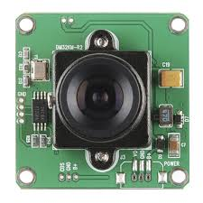

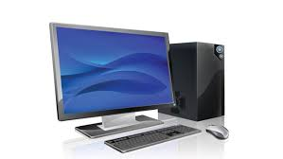



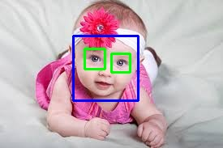



**Cloud**

## Activity Diagrams/ Flow Charts

Flow Chart:

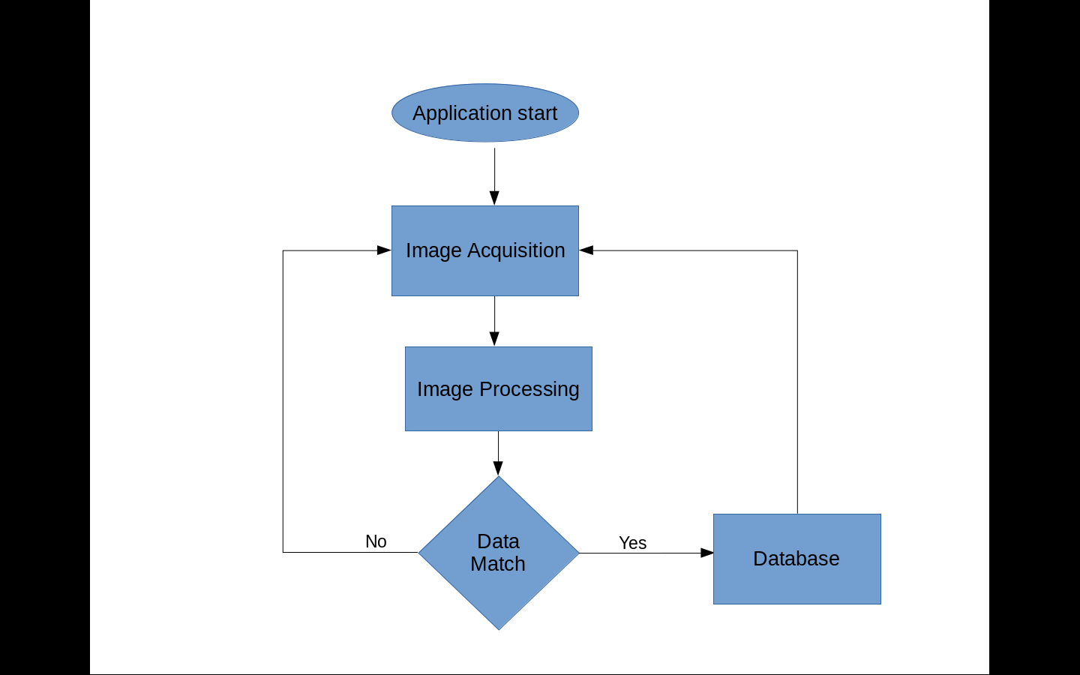

## Deployment diagrams

NA

## State Transition Diagram (Optional)

NA

## State Transition Table

NA

# Design

## Class Diagrams

NA

## Sequence Diagrams

## Database Design

NA

## Wireframes

NA

# Implementation

<Implementation details of the project.>

## Directory Structure

<Directory Structure for Project Repository for source code, documents, Reports etc >

## Libraries and Framework

<Give the details of Libraries, SDK or framework classes used from internal or 3rd parties to construct the project base. Packaging of libraries and their reference documentation>

## Error Handling

<Applicable for Module services, Success, Retry count, Failure error codes, that will be sent as response to clients/modules using the service.>

## Status Codes and Description

<List the Success/Warning/Failure Error codes that will be sent as response to clients/modules using the service and their description and severity.>

# Validate

<References to Checklists, Checklists for Detail Design Document, Review defect logs, Approval Emails, Traceability >

# Deploy

<Commit Base-lined Design Documents to SVN, Configure all the tools and raise Requests for Training, hardware, software and resources identified in the Plan>

# Maintain

<Changes to Design with appropriate references to CRs, Enhancements etc,>